Innovation Zone update

Purpose:
For information.

Summary
The report includes background details about the Zone, latest developments and members’ involvement.

Recommendation
That members note the report.
Actions
- Members to encourage attendance at the Innovation Zone (IZ) and get involved during the Conference.

- IZ working group to provide advice and guidance where necessary.

Lead Member: Cllr Peter Fleming OBE
Contact officer: Lusi Manukyan
Position: Improvement Support Adviser
Phone no: 0207 187 7347
Email: lusi.manukyan@local.gov.uk

Innovation Zone update
Background
- In addition to specific support offers such as the Behavioural Insights and Design in the Public Sector programmes, the LGA’s innovation programme includes sharing examples of local government and wider public sector good practice. This helps equip councils with tools and confidence to use innovative approaches to solve their challenges.

- The innovation programme includes our three-day Innovation Zone, which is a vibrant, creative space and programme within the LGA’s Annual Conference and Exhibition, taking place from 2-4 July 2019 in Bournemouth.

- Following a paper presented to the Board on 25 October 2018 and email consultation with members, it was agreed that this year’s overall theme for the Innovation Zone will be ‘Take the Plunge’, encouraging organisations to present brave, innovative ideas that have paid off.
Applications and shortlist
- The Innovation Zone opened for submissions in the first week of December 2018, with a deadline of 28 January 2019 and has been promoted through a number of channels including social media, the LGA website and various bulletins.
- We received over 70 applications to participate in the Zone from councils and other organisations working to improve outcomes in local communities though innovation.

- The quality of the applications was very high this year with a number of interesting ideas. Some of the broad emerging themes that we have identified include:

  - Health and social care
  - Environment, waste and sustainability
  - Data, analytics and tech
  - Tackling loneliness
  - Social justice and homelessness
  - Housing and regeneration
  - Children in care
  - Libraries and culture.

- The IIB Innovation Working group has overall oversight of the project and will consider a shortlist of 40 Innovation Zone participants, as well as the draft programme of the sessions, during a meeting on 28 March 2019.

- There is an opportunity for all members of the board to get involved in promoting the Innovation Zone both before and during the conference, and we would welcome any creative ideas in relation to this.

- Appendix 1 provides a full proposed project timeline with details of individual activities and deadlines.
Implications for Wales
- None.
Financial Implications
- There are no financial implications arising from this report.
Next steps
- Members to encourage attendance at the Innovation Zone and get involved during the Conference.

- IZ working group to provide advice and guidance where necessary.

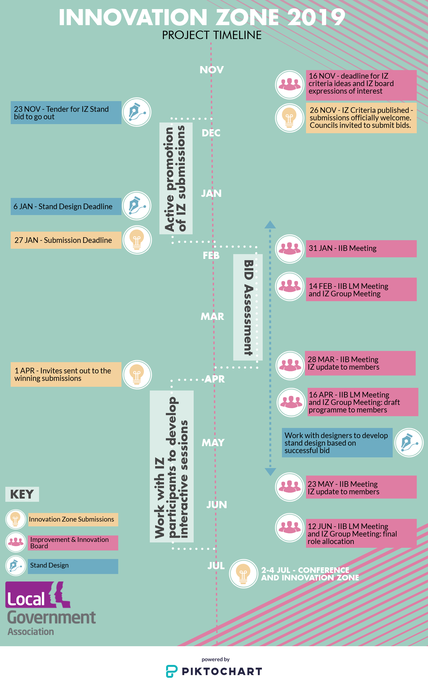
Appendix 1. Innovation Zone Project timeline

